生命科学学院
2019-2020学年第一学期
课程作业

课 程 名 称 《生物计算机编程语言》
姓 名 赵舒涵
学 号 18337201
专 业 生物技术与应用基地班
成 绩
任 课 教 师 郑凌伶

学习时间：2019年 9月至2019 年 12月

1.
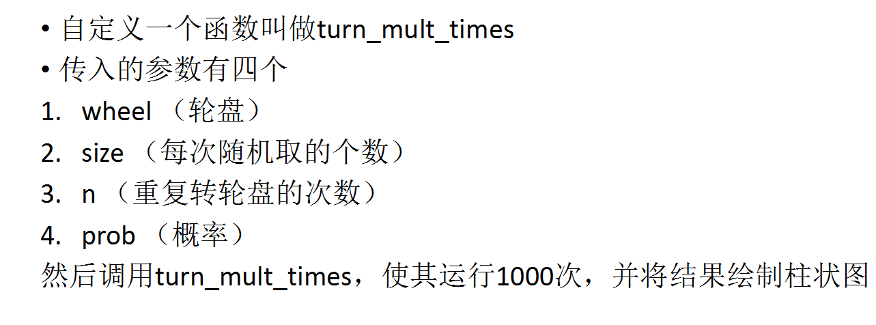

turn_mult_times<-function()
{
wheel<-2:5
workfir<-sample(wheel, size =2, replace =TRUE, prob =c(0.3, 0.1, 0.2, 0.4))
sum(workfir)
}
x<-replicate(1000,turn_mult_times())
hist(x)
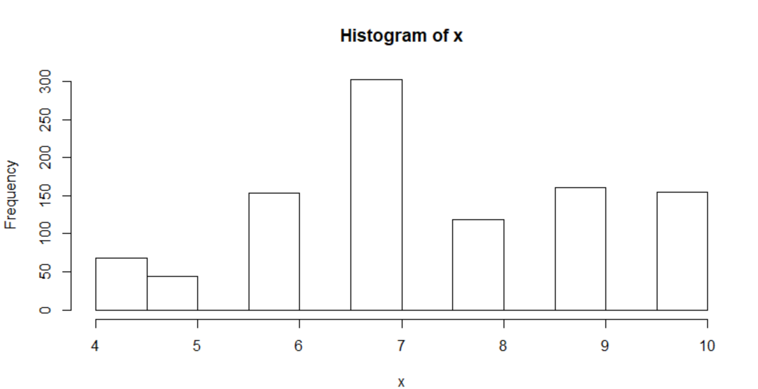
2.


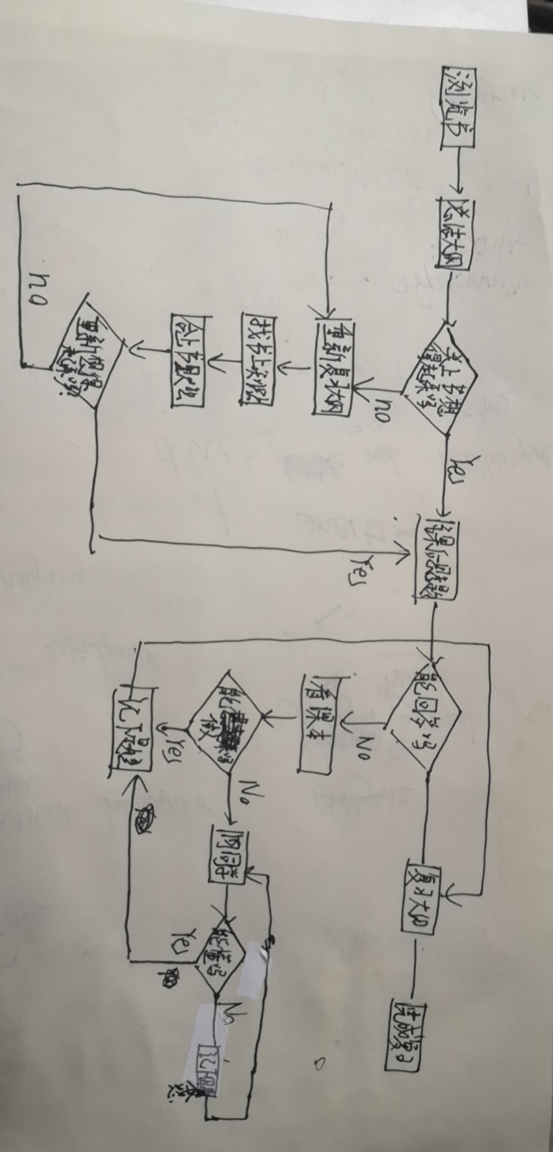

3.
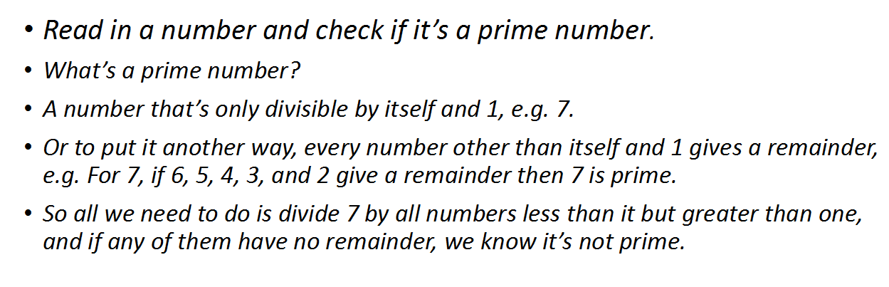
install.packages(schoolmath)
library("schoolmath")

is.prim(7)

prime <- function(x) {
if (any(x %% 2:(x - 1) == 0))
return("X is not a prime")
"X is a prime"
}
prime3(7)

4.

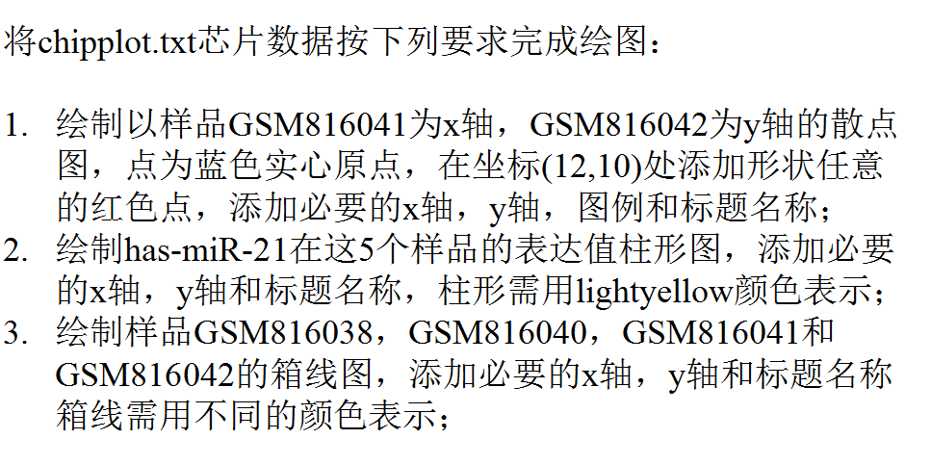
- ggplot(chip2, aes(x=V5, y=V6))
+ geom_point(size=1,shape=21,col="blue",bg="blue")
+geom_point(aes(12,10), col="red", size=3)
+geom_point(alpha = .5)
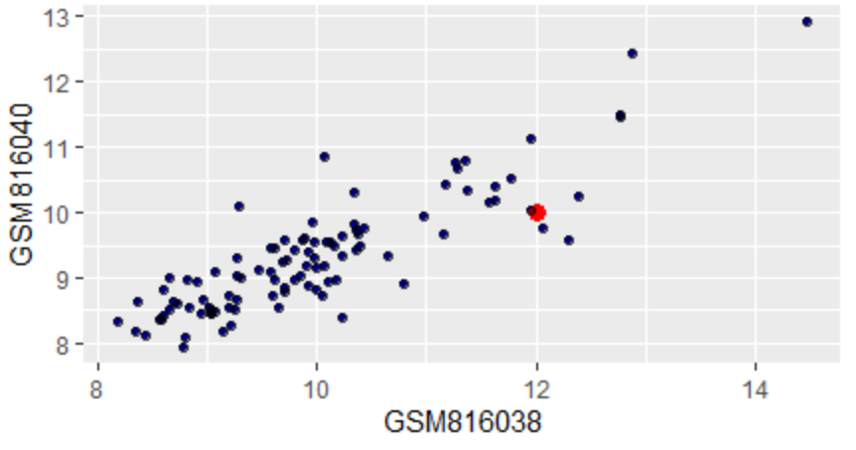
2. chip_bar<-c(t(chip1[93,2:6]))
chip_bar1<-as.numeric(chip_bar)
chip_bar1
barplot(chip_bar1,col="yellow",xlab = "has-mir-21",ylab = "expression",main=" has-mir-21 expression ")
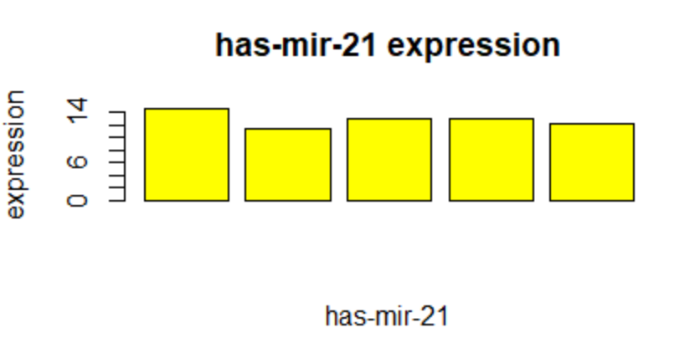

3. cheng<-data.frame(table(chip1$GSM816038,chip1$GSM816040,chip1$GSM816041,chip1$GSM816042))

boxplot(cheng,col=c("yellow","steelblue","steelblue","mediumturquoise"),xlab="chip1$GSM816038,chip1$GSM816040,chip1$GSM816041,chip1$GSM816042" , ylab="Length of AA",las=1, font.lab=2)
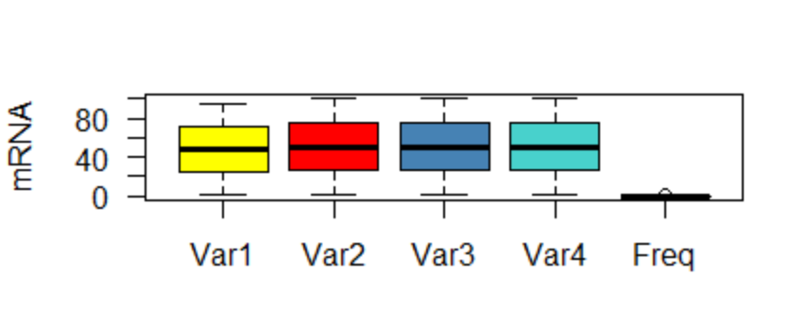

5.


install.packages("ggplot2")
library("ggplot2")
install.packages("survival")
library("survival")
data("lung")
head(lung)
s <-Surv(lung$time, lung$status)
sfit<-survfit(c(s~1))
sfit

fit <-survfit(Surv(time,status)~sex,data =lung)
print(fit)
plot(fit)
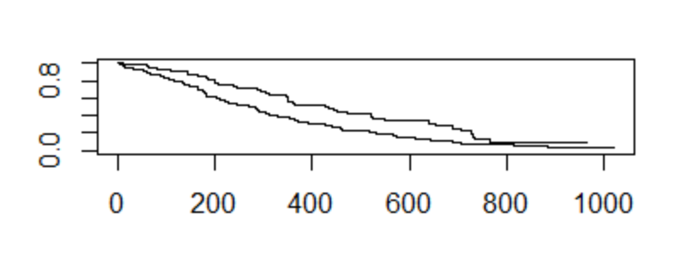
install.packages("survminer")
library("survminer")
ggsurvplot(fit)
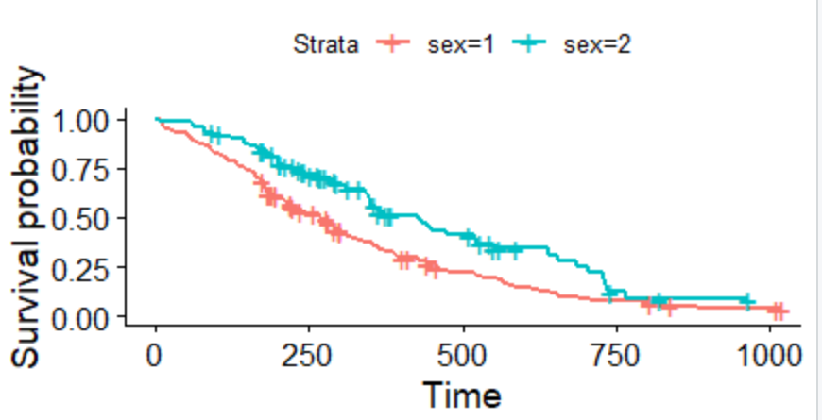
library(survival)
res.cox<-coxph(Surv(time,status)~ph.ecog,data = lung)
res.cox

> res.cox<-coxph(Surv(time,status)~ph.ecog,data = lung)
> res.cox
Call:
coxph(formula = Surv(time, status) ~ ph.ecog, data = lung)

coef exp(coef) se(coef) z p
ph.ecog 0.4759 1.6095 0.1134 4.198 2.69e-05

Likelihood ratio test=17.57 on 1 df, p=2.773e-05
n= 227, number of events= 164
(1 observation deleted due to missingness)

surv_diff <- survdiff(Surv(time, status) ~ ph.ecog, data = lung)
surv_diff

Call:
survdiff(formula = Surv(time, status) ~ ph.ecog, data = lung)

n=227, 1 observation deleted due to missingness.

N Observed Expected (O-E)^2/E (O-E)^2/V
ph.ecog=0 63 37 54.153 5.4331 8.2119
ph.ecog=1 113 82 83.528 0.0279 0.0573
ph.ecog=2 50 44 26.147 12.1893 14.6491
ph.ecog=3 1 1 0.172 3.9733 4.0040

Chisq= 22 on 3 degrees of freedom, p= 7e-05

res <- pairwise_survdiff(Surv(time, status) ~ph.ecog, data = lung )
res
Pairwise comparisons using Log-Rank test

data: lung and ph.ecog

0 1 2
1 0.07559 - -
2 0.00027 0.01105 -
3 0.03138 0.03138 0.26503

P value adjustment method: BH
#Log-Rank test的P值0.001也可得出ph.ecog组有显著差异

6. 请为自己出一道题
#1月份的第一天是星期三，一年中的第n天(如第三十二天)是星期几?
n=
day<-1:n
date<-ts(day,start = c(1,3),frequency = 7)
end(date)

n=32
#取end 结果的第二个数值

> n=
+ day<-1:n
> date<-ts(day,start = c(1,3),frequency = 7)
> end(date)
[1] 5 6
>
> n=32

所以是星期六

7. 请谈谈你对本门课程的意见和建议
我觉得这门课真的非常好，两位老师上课都用生物的例子来讲，而且层层递进，受益匪浅。

作业成绩评定
任课老师评语：

成绩评定：

2018年 月 日

